2016 Water Quality Summary Series - pH
Since 2003, water quality scientists have observed and sampled Barr Lake and Milton Reservoir twenty times a year by the dam for a variety of water quality parameters. These 260 trips to both reservoirs have produced an abundance of data and information. This is Part 1 of 8 2016 water quality summaries. This first summary focuses on pH and how it compares to other years.

The Big Picture – Many lakes, reservoirs, and even estuaries and bays throughout the world experience “cultural eutrophication”. This term means that water bodies tend to become more productive and shallower over relatively short periods of time due to increased inputs of nutrients and sediments from human impacts in the watershed. Eutrophication is a natural process, but it generally occurs over a much longer geological period. This accelerated aging of lakes causes a quick biological response – severe algae growth. This response then leads to other chemical and physical changes within the water column– pH, oxygen, water clarity, water color, and aesthetics.

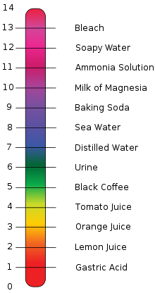
pH – This is the measurement of how many hydrogen ions (H⁺) are in the water (scale is 1 through 14). The higher the concentration of H⁺, the more acidic or lower the number (scale of 1-6). The lower the H⁺ concentration, the more basic or higher the number (scale of 8-14). Pure water has a neutral pH around 7.0. Normal rainfall is about 5.6.

For fish and other aquatic organisms and to satisfy Colorado’s water quality standard for lakes, the desired range is 6.5 to 9.0. To determine if a lake is satisfying this standard, pH data is collected from the surface (epilimnion) and bottom of the lake (hypolimnion).

2016 pH Data – For Barr Lake and Milton Reservoir, pH data are collected throughout the entire water column in half meter increments during each visit. pH data from 0.5 meter to 2.0 meters are then averaged for each visit for the top water. For 2016, there were 20 pH averages recorded for each reservoir (Table 1). The data is then ranked from highest to lowest. The 85th percentile pH value is the one that has 15% of the values higher and 85% of the values lower. For Barr Lake, the 2016 85th percentile pH value was 9.18 and for Milton Reservoir it was 8.92. For the past three years, Barr Lake has met the pH standard. For Milton, this was third time in four years.
Table 1. 2016 Barr Lake and Milton Reservoir average pH for the top water (0.5 – 2.0 m) for each sampling event and the 85th percentile. Bold values exceed the water quality standard.
Barr Lake |  |  |  |  | Milton Reservoir
Month | pH | Rank | %tile |  | Month | pH | Rank | %tile
Jan | 8.91 | 9.35 | 100 |  | Jan | 8.37 | 8.96 | 100
Feb | 8.24 | 9.31 |  |  | Feb | 8.30 | 8.95
Mar | 8.58 | 9.25 | 90 |  | Mar | 8.40 | 8.93 | 90
Mar | 8.92 | 9.18 | 85 |  | Mar | 8.31 | 8.92 | 85
Apr | 9.35 | 9.13 | 80 |  | Apr | 8.26 | 8.86 | 80
Apr | 8.53 | 9.07 |  |  | Apr | 8.14 | 8.86
May | 8.94 | 8.98 | 70 |  | May | 8.41 | 8.73 | 70
May | 8.06 | 8.94 |  |  | May | 8.41 | 8.72
Jun | 8.98 | 8.94 | 60 |  | Jun | 8.31 | 8.57 | 60
Jun | 8.92 | 8.93 |  |  | Jun | 8.57 | 8.42
Jul | 9.18 | 8.92 | 50 |  | Jul | 8.86 | 8.41 | 50
Jul | 9.25 | 8.92 |  |  | Jul | 8.73 | 8.41
Aug | 9.13 | 8.91 | 40 |  | Aug | 8.92 | 8.40 | 40
Aug | 8.80 | 8.90 |  |  | Aug | 8.86 | 8.37
Sep | 8.93 | 8.84 | 30 |  | Sep | 8.72 | 8.31 | 30
Sep | 9.07 | 8.80 |  |  | Sep | 8.93 | 8.31
Oct | 8.84 | 8.58 | 20 |  | Oct | 8.96 | 8.30 | 20
Oct | 8.90 | 8.53 |  |  | Oct | 8.95 | 8.26
Nov | 8.94 | 8.24 | 10 |  | Nov | 8.42 | 8.14 | 10
Dec | 9.31 | 8.06 |  |  | Dec | 8.10 | 8.10

The average pH for Barr Lake in 2016 was 8.89 and for Milton Reservoir it was 8.55. Both reservoirs experienced a typical spring time diatom bloom but then had a mild summer of algae growth. The lowest pH for Barr Lake occurred in May when the reservoir had little algal growth. For Milton, the lowest pH occurred during December when the reservoir started refilling and in April when algal productivity was low.

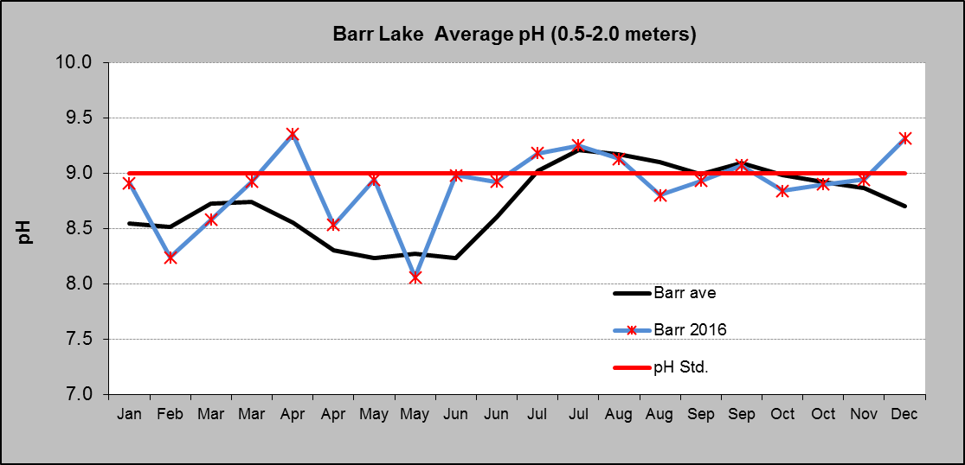
Applying the same statistical methods to just the growing season (July – September), Barr Lake‘s 85th percentile was 9.20, and Milton Reservoir’s 85th percentile was 8.92. Most of the growing season numbers are higher because of a focus on the three months of greater algae growth that causes the higher pH values.
Figure 1

Figures 1 and 2 show the annual pH patterns, pH standard, and 2016 pH numbers.
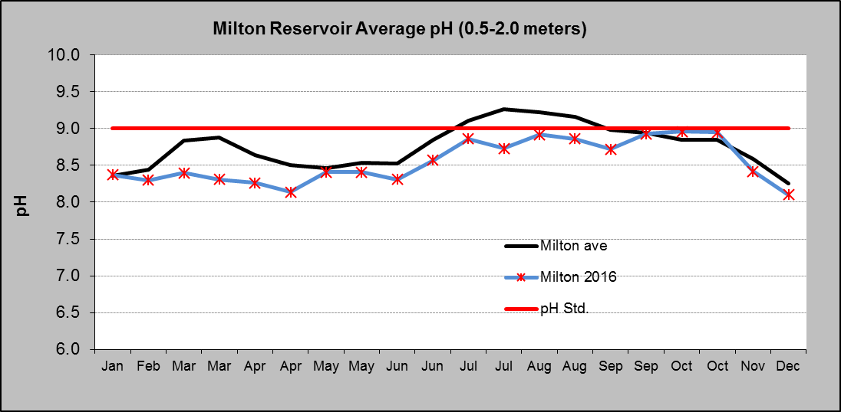
Algae and pH – How does the growth of algae change the pH of a lake? When algae grow, they undergo photosynthesis. This is the process of taking in CO₂ and water in the presence of sunlight and producing oxygen and sugar (food) for growth. Taking CO₂ out of the water results in less carbonic acid (H₂CO₃). Less carbonic acid means less H⁺ in the water, and therefore a higher pH. If the algae grow too fast, the reservoir does not have enough time to get back into equilibrium with the atmosphere to dissolve more CO₂.
Figure 2

The opposite can occur; decomposition of the algae at the lake bottom takes in oxygen and produces CO₂. Bottom water can get below pH of 6.0 (acidic) because of the carbonic acid formation. Due to water movement and alkalinity (ability of the water to neutralize acids), this does not happen in Barr Lake or Milton Reservoir.

